Electrical Automation Technology, Control Systems Technology & Electrical Systems Design Technology
Performance Test #6, GFCI Receptacle

Name ____________________________ Instructor Verification __________ Grade _________

Material:
Materials Provided by You | Materials Provided by the Department
1. Necessary Tools | 1. GFCI Receptacle
2. 14/2 w/Ground NM-B or MC Cable | 2. Duplex Receptacle
3. Wire Kit | 3. Single Pole Switch
 | 4. Lamp Holder

Objective:
Given necessary materials, the student will construct an electrical circuit in 60 minutes, as evidenced by scoring a minimum of 75% on this test.

Time Limit:
You are allowed 60 minutes to complete the circuit. Ten points for every five minutes over the allotted time will be deducted from the score. The maximum overtime allowed is fifteen minutes.

Description of the Circuit:
Construct a circuit in which the duplex receptacle is protected by the GFCI receptacle. Both receptacles are “hot” at all times. The lamp holder is controlled by the single pole switch. Power is fed to the single pole switch box. Power from the single pole switch box is fed to the GFCI receptacle box. All devices and lamp are installed in metal boxes.

Part 1 (+20 points)
Using a straight edge, draw how this circuit will be wired.
Start Time__________ Finish Time__________

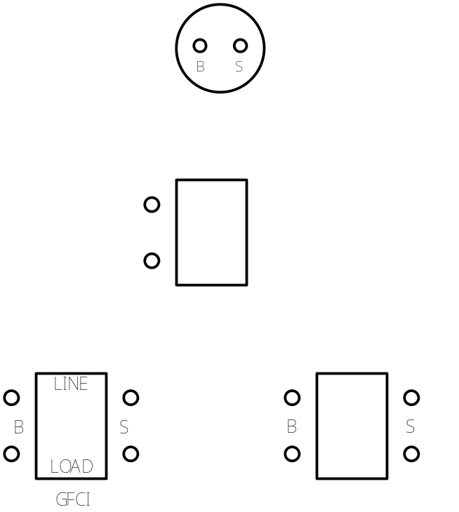
Performance Test # 6

Part #2 (80 points):

Construct the circuit.

__________ Circuit wired to the NEC and fitting tight. +10 points

__________ 6” of free conductor from the edge of the box. +5 points

__________ Wire nut connections secure. +10 points

________ Conductors on devices correctly. +10 points

__________ 1/4” of cable sheath inside box. +5 points (if NM-B is used)

__________ All anti-short bushings in place. +5 points (if MC is used)

__________ Circuit works as described. +40 points (troubleshooting yourself +10 points)

